**Assignment No-2**

**2) Write HTML/CSS to display your CV in navigator, your Institute website, Department Website and Tutorial website for specific subject.**

**Prerequisite:** HTML, CSS, FORM Tag

**Skilled Developed:** Student shall be able to design the CV with the use of all required tags.

**Description:**

In this application a CV will be designed with detailed information and displayed on page.

**Expected output:**

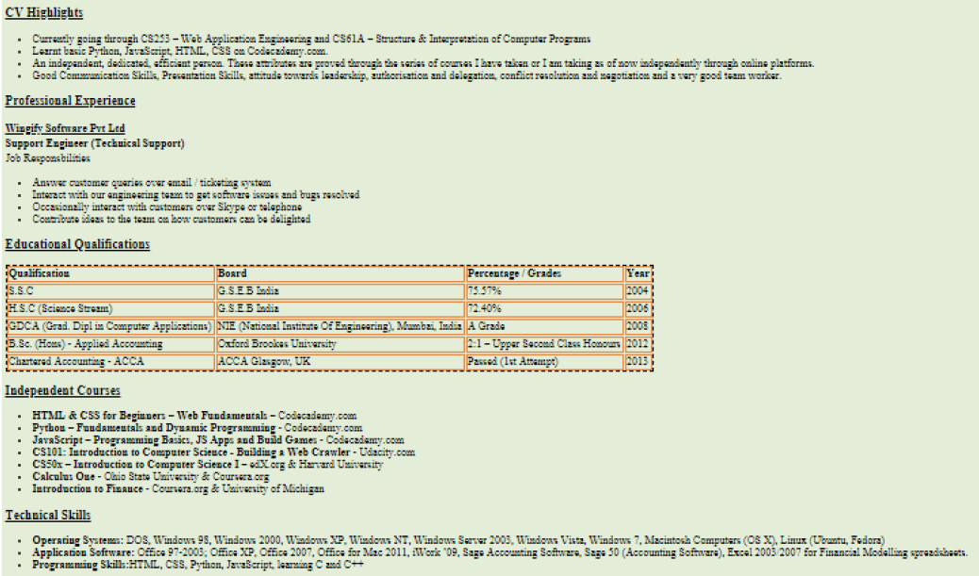 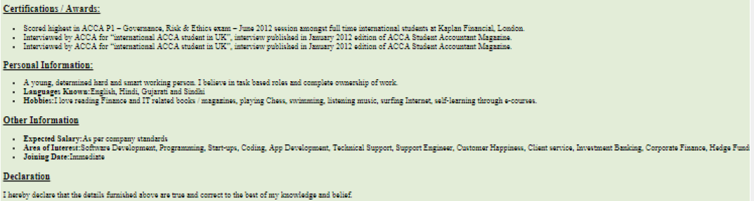

**References:**

1. *Web Technologies- A computer science perspective By Jeffery C. Jackson, Pearson*
2. *Web Technologies-TCP/IP Architecture, and Java Programming By Achyut S. Godbole*
3. *Web Technology-A Developer’s Perspective by N.P Gopalan,J.Akilandeswari,PHI Learning*

**FAQ**

1. What is CSS and its type?
2. What are the selector in CSS?
3. what are basic and misleanous tag in the html?
4. What are the types of list in html?